Rainfall Depth-Duration-Frequency Analysis
Site / series: synthetic Generated: 2026-09-28 Tool: Mayim Tools - Precipitation Data to DDF

1. Purpose
This report documents the derivation of a Depth-Duration-Frequency (DDF) table from a recorded precipitation time series (gauge, or gridded reanalysis / satellite product). Annual maximum series (AMS) are extracted at each duration, frequency distributions are fitted, and a single duration-consistent DDF model is fitted across all durations so that the recommended design depths always increase with both duration and return period. Per-duration fits and the L-moment ratio diagram are reported as diagnostics.

2. Inputs and data
Item | Value
Rainfall series | synthetic.csv
Record | 1980-01-01 02:00:00 to 2020-01-01 01:00:00
Native time step | 60 min
Time-zone offset applied | 2.0 h
Year definition | calendar year
Years in record / used | 41 / 40 (minimum completeness 90%)
Years excluded | 2020
Durations analysed | 1 h, 2 h, 3 h, 4 h, 6 h, 8 h, 10 h, 12 h, 16 h, 20 h, 24 h, 48 h, 72 h, 96 h, 120 h, 144 h, 168 h
Fixed-interval correction | Weiss (1964) 1/(1-1/(8n))
Distributions fitted per duration | GEV, Gumbel, GLO, LP3
GEV fitting method (per duration) | L-moments
DDF model distribution | GEV
DDF model growth curve | smoothed L-CV and L-skewness
Bootstrap | 200 replicates (seed 42)

3. Method
Annual maximum series. For each duration the maximum depth accumulated in a sliding window of that length is extracted for each calendar year. Missing data are never treated as zero; years whose completeness is below the threshold are excluded from every duration so that all durations share the same years. Return periods are annual-maximum values (AEP = 1/T).
Fixed-interval correction. Maxima from data recorded at a fixed interval under-estimate the true (unrestricted) maxima because a storm rarely aligns with the clock. Each window of n native steps was multiplied by the Weiss (1964) factor 1/(1 - 1/(8n)), e.g. 1.143 for n = 1, 1.018 for n = 6 and 1.005 for n = 24.
Per-duration fits (diagnostic). The GEV, Gumbel, GLO and LP3 distributions are fitted independently to each duration by L-moments (Hosking & Wallis 1997). The L-moment ratio diagram (Vogel & Fennessey 1993) ranks the candidates at each duration by the distance between the sample (tau3, tau4) and each distribution's theoretical curve (Gumbel: a single point, measured in both tau3 and tau4). Fitting each duration separately - and especially selecting a different distribution for each duration - can produce DDF curves that cross, i.e. a longer duration with a smaller design depth, which is physically impossible. These fits are therefore reported for review only.
Duration-consistent DDF model (recommended). Following the index-flood-across-durations framework of Koutsoyiannis et al. (1998) and Overeem et al. (2008), the annual maximum depth X_d at duration d (minutes) is written as X_d = l1(d) * Y_d, where the mean scales smoothly with duration, l1(d) = lambda1 * (d/60) * ((d + theta)/(60 + theta))^(-eta) with theta >= 0 and 0 <= eta < 1 (strictly increasing in d), and Y_d is a growth variable with mean 1 and a single distribution family (GEV by default). theta, eta and lambda1 are fitted by record-length-weighted least squares on the logarithm of the sample means.
Growth curve. Short durations are typically more variable and more skewed than long durations, so the L-CV and L-skewness of Y_d are allowed to vary smoothly with duration: L-CV(d) = cv60 * (d/60)^beta and tau3(d) = tau3_60 + g * ln(d/60), fitted by weighted least squares to the sample L-moments of all durations. This smooths the at-site L-moments across durations (cf. the regression smoothing of L-moments across durations in the ARR 2016 IFDs; Ball et al. 2019) instead of fitting each duration in isolation, which borrows strength across durations and damps sampling noise in the shape parameter.
Consistency. The model table is checked for depths increasing with duration and return period; any remaining crossings (typically only possible at the longest durations or rarest return periods, where the fitted L-skewness trend is extrapolated) are removed by isotonic regression (pool-adjacent-violators; Barlow et al. 1972), as proposed for IDF curves by Roksvag et al. (2021). The size of any such correction is reported.
Uncertainty. 5-95% bounds are from 200 non-parametric bootstrap replicates (Efron & Tibshirani 1993) in which whole years are resampled with replacement - the same years for every duration, so the dependence between durations is preserved - and the full model (scaling, growth curve and consistency step) is refitted each time. The bounds express sampling uncertainty only, not uncertainty in the data themselves or in the choice of model.

4. DDF model parameters
Parameter | Value
Distribution of growth variable | GEV
lambda1 (mean AMS at 60 min) | 26.22 mm
theta | 47.9 min
eta | 0.923
cv60 (L-CV at 60 min) | 0.202
beta (L-CV duration exponent) | -0.031
tau3 at 60 min | 0.142
g (tau3 change per ln-duration) | 0.012
RMSE of ln(mean) fit | 0.024
RMSE of ln(L-CV) fit | 0.086
RMSE of tau3 fit | 0.056
Notes | -
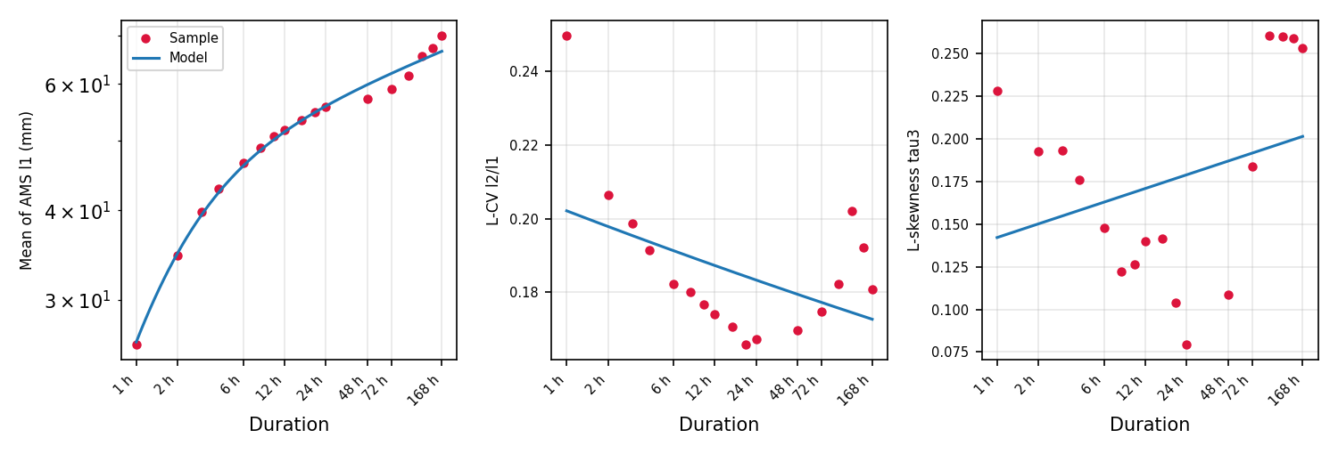
Figure 1. Sample L-moments per duration (points) and the smooth DDF-model curves (lines).

5. Recommended DDF
Design depths (mm) from the duration-consistent model, with 5-95% bootstrap bounds in brackets.
Duration | 1.0101-yr | 1.11111-yr | 2-yr | 5-yr | 10-yr | 20-yr | 50-yr | 100-yr | 200-yr | 500-yr
1 h | 9.4  (5.7-13.4) | 15.2  (13.1-18.3) | 24.9  (22.3-27.8) | 33.5  (29.5-38.3) | 39.0  (32.7-45.1) | 44.1  (36.1-51.3) | 50.5  (39.7-60.6) | 55.1  (41.9-68.6) | 59.5  (43.8-76.2) | 65.2  (46.1-87.0)
2 h | 13.3  (9.1-17.6) | 20.6  (18.1-23.8) | 33.0  (30.1-36.0) | 44.3  (39.7-49.0) | 51.5  (44.8-57.4) | 58.3  (49.7-65.4) | 66.9  (55.2-76.4) | 73.1  (58.4-85.6) | 79.2  (61.1-95.1) | 87.1  (64.2-108.2)
3 h | 15.5  (11.0-19.9) | 23.6  (21.0-27.0) | 37.3  (34.3-40.5) | 49.9  (45.0-54.3) | 58.1  (51.5-63.5) | 65.7  (57.1-72.3) | 75.5  (63.2-84.0) | 82.7  (67.5-93.6) | 89.7  (70.1-103.7) | 98.8  (74.1-118.3)
4 h | 17.0  (12.6-21.7) | 25.5  (22.9-29.1) | 40.1  (37.0-43.5) | 53.5  (48.5-58.0) | 62.2  (55.7-67.5) | 70.5  (62.0-77.1) | 81.0  (69.0-89.0) | 88.8  (73.6-99.2) | 96.4  (77.0-108.9) | 106.4  (82.2-124.1)
6 h | 19.0  (14.6-24.3) | 28.1  (25.3-31.6) | 43.5  (40.3-47.7) | 58.0  (52.7-62.7) | 67.4  (60.7-73.0) | 76.4  (67.8-82.7) | 87.9  (76.3-95.4) | 96.5  (81.5-105.4) | 104.9  (86.8-115.9) | 116.0  (93.5-131.2)
8 h | 20.4  (15.9-26.0) | 29.7  (27.0-33.5) | 45.7  (42.1-50.2) | 60.8  (55.4-65.6) | 70.6  (63.9-76.1) | 80.1  (71.6-85.8) | 92.3  (81.1-99.0) | 101.3  (87.4-109.2) | 110.3  (93.1-120.4) | 122.2  (100.1-136.1)
10 h | 21.4  (16.9-27.2) | 30.9  (28.1-34.8) | 47.3  (43.6-51.8) | 62.7  (57.3-67.9) | 72.9  (66.2-78.3) | 82.7  (74.6-88.5) | 95.3  (84.5-101.9) | 104.8  (91.3-112.4) | 114.2  (97.3-123.6) | 126.6  (105.1-139.3)
12 h | 22.2  (17.6-28.1) | 31.8  (28.9-35.8) | 48.5  (44.7-53.2) | 64.2  (58.9-69.5) | 74.7  (68.0-80.1) | 84.7  (76.5-90.4) | 97.7  (86.9-103.8) | 107.5  (94.1-114.3) | 117.2  (100.9-125.7) | 130.0  (109.9-142.2)
16 h | 23.5  (19.0-29.3) | 33.3  (30.3-37.3) | 50.3  (46.4-55.1) | 66.5  (61.2-71.9) | 77.3  (70.7-83.3) | 87.7  (79.7-93.2) | 101.2  (90.7-106.6) | 111.4  (99.0-118.1) | 121.6  (105.8-129.9) | 135.2  (114.2-147.1)
20 h | 24.4  (19.9-30.0) | 34.3  (31.4-38.5) | 51.6  (47.7-56.4) | 68.1  (62.8-73.7) | 79.1  (72.8-85.3) | 89.8  (82.0-95.7) | 103.8  (93.6-109.3) | 114.3  (102.2-120.6) | 124.9  (109.7-133.1) | 138.9  (117.9-151.5)
24 h | 25.2  (20.6-30.9) | 35.2  (32.2-39.4) | 52.6  (48.6-57.8) | 69.4  (64.1-75.4) | 80.6  (74.1-86.6) | 91.5  (83.7-97.6) | 105.7  (95.8-111.4) | 116.5  (104.9-123.1) | 127.4  (112.2-136.2) | 141.9  (121.6-155.0)
48 h | 28.1  (23.5-33.9) | 38.2  (35.4-42.7) | 56.3  (52.3-61.5) | 73.8  (67.6-80.5) | 85.7  (78.4-92.4) | 97.4  (89.0-104.3) | 112.8  (102.7-120.0) | 124.6  (111.3-134.0) | 136.6  (119.1-148.8) | 152.7  (129.6-173.7)
72 h | 29.8  (25.0-35.8) | 40.0  (37.1-44.5) | 58.3  (54.1-64.3) | 76.3  (69.5-83.7) | 88.6  (80.7-96.3) | 100.6  (90.9-108.5) | 116.7  (104.3-125.8) | 129.1  (114.3-141.1) | 141.7  (121.5-160.1) | 158.8  (131.0-185.7)
96 h | 31.0  (25.8-37.1) | 41.3  (38.2-45.9) | 59.7  (55.6-66.2) | 78.0  (71.5-85.6) | 90.5  (81.9-98.8) | 102.9  (92.9-111.4) | 119.4  (105.4-130.0) | 132.2  (115.1-145.5) | 145.3  (122.4-166.0) | 163.1  (131.7-195.4)
120 h | 31.9  (26.9-38.2) | 42.2  (39.1-47.0) | 60.9  (56.6-67.9) | 79.3  (72.5-87.3) | 92.1  (82.9-100.9) | 104.6  (93.8-114.3) | 121.5  (106.2-134.2) | 134.6  (115.8-149.6) | 148.1  (122.9-172.2) | 166.5  (132.0-205.3)
144 h | 32.7  (27.3-38.8) | 43.1  (39.8-47.9) | 61.8  (57.4-69.0) | 80.4  (73.2-88.8) | 93.3  (83.7-102.8) | 106.1  (94.3-116.3) | 123.3  (106.8-136.5) | 136.6  (116.3-153.7) | 150.4  (123.3-177.1) | 169.2  (132.2-212.0)
168 h | 33.4  (27.7-39.4) | 43.7  (40.5-48.7) | 62.5  (58.2-69.9) | 81.3  (73.8-90.2) | 94.3  (84.4-104.1) | 107.3  (94.7-118.0) | 124.7  (107.3-138.3) | 138.3  (116.7-157.7) | 152.3  (123.8-180.6) | 171.5  (132.4-217.2)
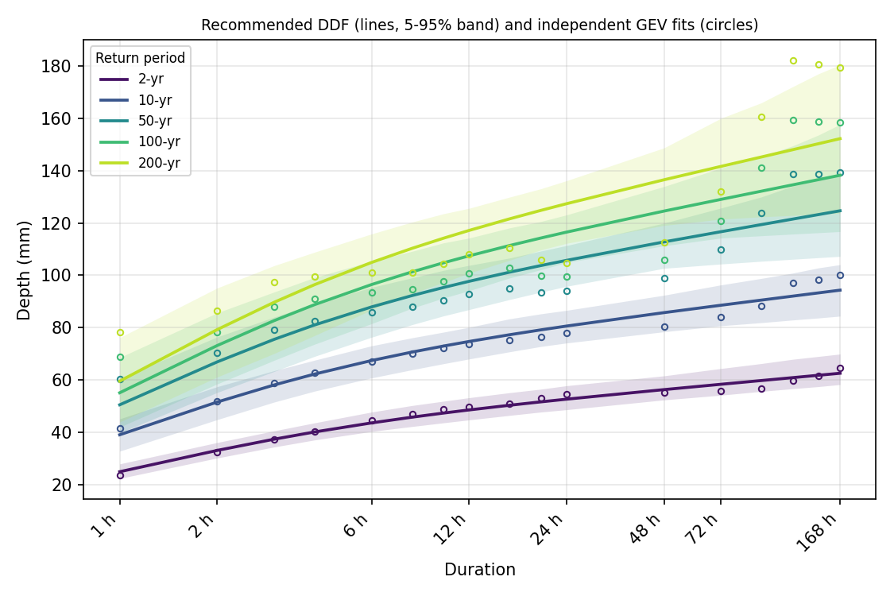
Figure 2. Recommended DDF curves with 5-95% bands (lines) and independent per-duration GEV quantiles (circles).

6. Diagnostics

6.1 Annual maximum series
Duration | Years | Mean (mm) | Min (mm) | Max (mm) | Year of max | Weiss
1 h | 40 | 26.0 | 8.2 | 61.8 | 1997 | 1.143
2 h | 40 | 34.6 | 14.0 | 72.8 | 1997 | 1.067
3 h | 40 | 39.8 | 17.7 | 78.0 | 1997 | 1.043
4 h | 40 | 42.8 | 19.8 | 78.9 | 1997 | 1.032
6 h | 40 | 46.6 | 21.0 | 83.6 | 1998 | 1.021
8 h | 40 | 48.9 | 21.1 | 86.0 | 1998 | 1.016
10 h | 40 | 50.7 | 22.4 | 86.3 | 1998 | 1.013
12 h | 40 | 51.8 | 24.0 | 86.1 | 1998 | 1.011
16 h | 40 | 53.3 | 25.8 | 92.7 | 1989 | 1.008
20 h | 40 | 54.7 | 26.3 | 95.8 | 1989 | 1.006
24 h | 40 | 55.8 | 26.3 | 96.3 | 1989 | 1.005
48 h | 40 | 57.1 | 26.2 | 96.2 | 1989 | 1.003
72 h | 40 | 59.1 | 30.5 | 110.8 | 1987 | 1.002
96 h | 40 | 61.7 | 34.5 | 119.5 | 2012 | 1.001
120 h | 40 | 65.6 | 34.5 | 135.8 | 1983 | 1.001
144 h | 40 | 67.4 | 35.4 | 137.4 | 1983 | 1.001
168 h | 40 | 70.1 | 42.7 | 137.4 | 1983 | 1.001

6.2 Sample L-moments and ratio-diagram ranking
Duration | l1 (mm) | L-CV | tau3 | tau4 | Closest | Distances
1 h | 26.0 | 0.250 | 0.228 | 0.233 | GLO | GLO 0.023, GEV 0.057, LP3 0.094, GUMBEL 0.101
2 h | 34.6 | 0.206 | 0.192 | 0.207 | GLO | GLO 0.010, GEV 0.048, GUMBEL 0.061, LP3 0.072
3 h | 39.8 | 0.199 | 0.193 | 0.173 | GEV | GEV 0.013, GLO 0.025, GUMBEL 0.032, LP3 0.037
4 h | 42.8 | 0.191 | 0.176 | 0.160 | GEV | GEV 0.007, GUMBEL 0.011, LP3 0.026, GLO 0.033
6 h | 46.6 | 0.182 | 0.148 | 0.143 | GEV | GEV 0.001, LP3 0.013, GUMBEL 0.023, GLO 0.042
8 h | 48.9 | 0.180 | 0.122 | 0.119 | LP3 | LP3 0.008, GEV 0.014, GUMBEL 0.057, GLO 0.060
10 h | 50.7 | 0.177 | 0.126 | 0.107 | LP3 | LP3 0.021, GEV 0.028, GUMBEL 0.061, GLO 0.073
12 h | 51.8 | 0.174 | 0.140 | 0.116 | LP3 | LP3 0.013, GEV 0.023, GUMBEL 0.046, GLO 0.067
16 h | 53.3 | 0.171 | 0.141 | 0.130 | LP3 | LP3 0.001, GEV 0.010, GUMBEL 0.035, GLO 0.053
20 h | 54.7 | 0.166 | 0.104 | 0.137 | GEV | GEV 0.009, LP3 0.010, GLO 0.039, GUMBEL 0.067
24 h | 55.8 | 0.167 | 0.079 | 0.105 | GEV | GEV 0.017, LP3 0.020, GLO 0.067, GUMBEL 0.101
48 h | 57.1 | 0.170 | 0.109 | 0.088 | LP3 | LP3 0.039, GEV 0.041, GUMBEL 0.087, GLO 0.088
72 h | 59.1 | 0.175 | 0.184 | 0.105 | LP3 | LP3 0.029, GUMBEL 0.048, GEV 0.051, GLO 0.090
96 h | 61.7 | 0.182 | 0.261 | 0.166 | LP3 | LP3 0.019, GEV 0.027, GLO 0.058, GUMBEL 0.092
120 h | 65.6 | 0.202 | 0.260 | 0.137 | LP3 | LP3 0.009, GEV 0.055, GLO 0.086, GUMBEL 0.091
144 h | 67.4 | 0.192 | 0.259 | 0.126 | LP3 | LP3 0.020, GEV 0.066, GUMBEL 0.092, GLO 0.096
168 h | 70.1 | 0.181 | 0.253 | 0.114 | LP3 | LP3 0.031, GEV 0.075, GUMBEL 0.091, GLO 0.107
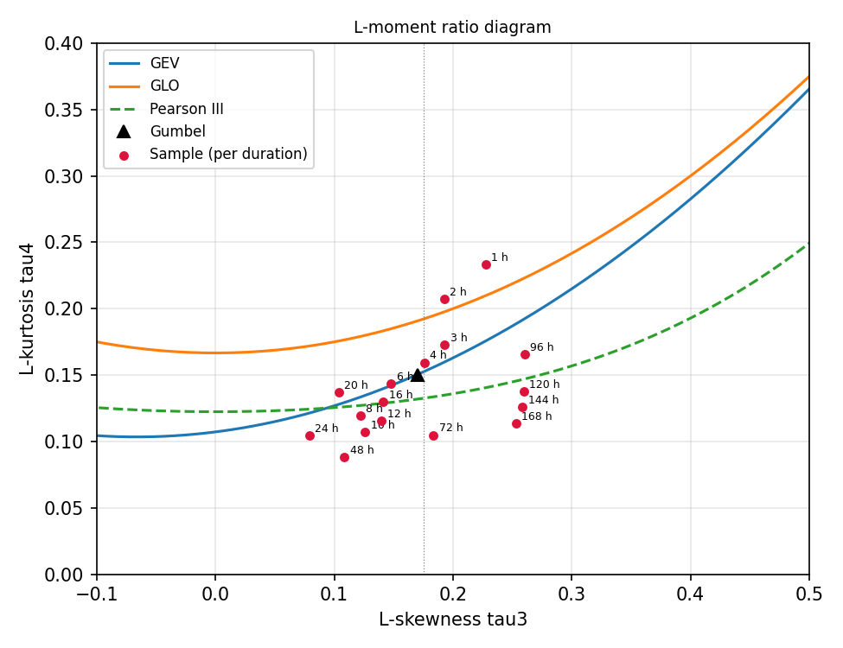
Figure 3. L-moment ratio diagram. Scatter between durations about the theoretical curves is expected from sampling variability; a systematic position supports the chosen model distribution.

6.3 Model versus independent GEV fits
Difference between the recommended (model) depth and a GEV fitted to that duration alone. Moderate differences are expected - the model pools information across durations - and are usually well within the bootstrap bounds. Large differences at one duration can indicate data problems (e.g. a single dominant storm) or that the smooth duration trend does not suit that duration.
Duration | 2-yr model / GEV (diff) | 10-yr model / GEV (diff) | 50-yr model / GEV (diff) | 100-yr model / GEV (diff)
1 h | 24.9 / 23.4 (6%) | 39.0 / 41.6 (-6%) | 50.5 / 60.2 (-16%) | 55.1 / 68.9 (-20%)
2 h | 33.0 / 32.2 (2%) | 51.5 / 51.9 (-1%) | 66.9 / 70.2 (-5%) | 73.1 / 78.3 (-7%)
3 h | 37.3 / 37.1 (1%) | 58.1 / 58.8 (-1%) | 75.5 / 79.2 (-5%) | 82.7 / 88.1 (-6%)
4 h | 40.1 / 40.3 (-1%) | 62.2 / 62.6 (-1%) | 81.0 / 82.6 (-2%) | 88.8 / 91.1 (-3%)
6 h | 43.5 / 44.3 (-2%) | 67.4 / 67.1 (0%) | 87.9 / 85.9 (2%) | 96.5 / 93.5 (3%)
8 h | 45.7 / 47.0 (-3%) | 70.6 / 70.1 (1%) | 92.3 / 87.9 (5%) | 101.3 / 94.7 (7%)
10 h | 47.3 / 48.6 (-3%) | 72.9 / 72.2 (1%) | 95.3 / 90.5 (5%) | 104.8 / 97.6 (7%)
12 h | 48.5 / 49.5 (-2%) | 74.7 / 73.6 (2%) | 97.7 / 92.9 (5%) | 107.5 / 100.7 (7%)
16 h | 50.3 / 51.0 (-1%) | 77.3 / 75.3 (3%) | 101.2 / 94.9 (7%) | 111.4 / 102.8 (8%)
20 h | 51.6 / 53.0 (-3%) | 79.1 / 76.5 (3%) | 103.8 / 93.6 (11%) | 114.3 / 99.9 (14%)
24 h | 52.6 / 54.4 (-3%) | 80.6 / 78.0 (3%) | 105.7 / 94.0 (12%) | 116.5 / 99.7 (17%)
48 h | 56.3 / 55.2 (2%) | 85.7 / 80.4 (7%) | 112.8 / 99.0 (14%) | 124.6 / 106.0 (18%)
72 h | 58.3 / 55.7 (5%) | 88.6 / 84.0 (5%) | 116.7 / 109.7 (6%) | 129.1 / 120.9 (7%)
96 h | 59.7 / 56.6 (5%) | 90.5 / 88.4 (2%) | 119.4 / 123.8 (-3%) | 132.2 / 141.3 (-6%)
120 h | 60.9 / 59.7 (2%) | 92.1 / 97.2 (-5%) | 121.5 / 138.9 (-12%) | 134.6 / 159.5 (-16%)
144 h | 61.8 / 61.6 (0%) | 93.3 / 98.2 (-5%) | 123.3 / 138.8 (-11%) | 136.6 / 158.9 (-14%)
168 h | 62.5 / 64.6 (-3%) | 94.3 / 100.3 (-6%) | 124.7 / 139.4 (-11%) | 138.3 / 158.6 (-13%)

7. Warnings
- Skipped duration(s) that are not whole multiples of the data's native interval (60 min): [90] minutes.
- 1 of 41 year(s) excluded from ALL durations' AMS for completeness below 90% - see the year-completeness diagnostic output.

8. Limitations and use
- Single-site frequency analysis. Record lengths of 20-40 years give reliable estimates up to roughly 2-3 times the record length; depths for rarer return periods are extrapolations and the bootstrap bounds widen accordingly. For design, compare with published regional DDF values (e.g. Smithers & Schulze 2003 / Design Rainfall for South Africa; ARR 2019 IFDs for Western Australia).
- Gridded products (ERA5, IMERG, CMORPH ...) represent grid-cell averages; their DDF is an areal, product-specific DDF and typically under-estimates point depths at short durations and rare return periods. Use the Adjust Sub-daily Rainfall to DDF tool to reconcile a gridded series with a gauge-based DDF.
- The bootstrap bounds reflect sampling uncertainty only.

Appendix A. Annual maximum series (mm)
Year | 1 h | 2 h | 3 h | 4 h | 6 h | 8 h | 10 h | 12 h | 16 h | 20 h | 24 h | 48 h
1980 | 23.3 | 27.6 | 29.2 | 29.4 | 29.1 | 29.0 | 32.9 | 36.2 | 40.8 | 43.7 | 43.7 | 43.6
1981 | 8.9 | 15.1 | 17.7 | 19.8 | 21.0 | 21.1 | 22.4 | 24.0 | 25.8 | 26.3 | 26.3 | 26.2
1982 | 21.4 | 21.4 | 22.0 | 23.9 | 29.1 | 32.3 | 34.2 | 35.3 | 36.4 | 38.3 | 40.1 | 41.0
1983 | 23.9 | 39.4 | 44.1 | 48.5 | 58.1 | 65.4 | 70.1 | 73.2 | 76.4 | 77.1 | 77.1 | 76.9
1984 | 23.6 | 34.9 | 39.3 | 41.8 | 43.3 | 43.7 | 47.0 | 49.2 | 50.9 | 51.1 | 51.2 | 51.0
1985 | 43.2 | 40.8 | 39.9 | 39.5 | 39.1 | 39.8 | 42.7 | 44.1 | 48.7 | 50.1 | 59.9 | 88.3
1986 | 16.3 | 28.6 | 38.1 | 46.5 | 58.6 | 65.0 | 67.9 | 67.8 | 67.6 | 67.5 | 67.4 | 67.2
1987 | 28.3 | 39.7 | 48.1 | 50.9 | 52.1 | 52.4 | 52.8 | 53.5 | 56.4 | 62.8 | 76.1 | 83.6
1988 | 27.1 | 37.1 | 46.5 | 55.2 | 64.8 | 68.8 | 68.6 | 68.5 | 68.3 | 68.2 | 68.1 | 67.9
1989 | 33.6 | 34.8 | 36.8 | 41.9 | 51.3 | 62.8 | 76.2 | 84.5 | 92.7 | 95.8 | 96.3 | 96.2
1990 | 28.6 | 38.1 | 45.6 | 48.6 | 51.7 | 52.6 | 52.7 | 52.6 | 52.5 | 52.4 | 52.4 | 52.2
1991 | 15.0 | 23.3 | 31.4 | 36.8 | 45.3 | 50.6 | 54.0 | 56.0 | 58.1 | 58.9 | 59.1 | 58.9
1992 | 19.0 | 29.4 | 35.6 | 39.6 | 41.6 | 41.7 | 42.5 | 43.1 | 43.9 | 56.6 | 65.3 | 68.3
1993 | 37.1 | 49.6 | 60.4 | 64.0 | 65.3 | 65.2 | 65.0 | 64.9 | 64.7 | 64.6 | 64.5 | 64.3
1994 | 13.9 | 24.9 | 31.3 | 37.2 | 42.4 | 43.8 | 44.2 | 44.2 | 44.1 | 44.1 | 44.0 | 43.9
1995 | 18.0 | 21.8 | 22.8 | 22.6 | 25.4 | 27.2 | 29.5 | 31.6 | 34.0 | 34.7 | 34.6 | 34.5
1996 | 8.2 | 14.0 | 20.0 | 24.9 | 34.0 | 40.2 | 44.6 | 47.6 | 51.1 | 52.8 | 53.6 | 53.4
1997 | 61.8 | 72.8 | 78.0 | 78.9 | 78.8 | 78.4 | 78.2 | 78.0 | 77.8 | 77.7 | 77.6 | 77.4
1998 | 52.0 | 53.4 | 64.9 | 74.1 | 83.6 | 86.0 | 86.3 | 86.1 | 85.9 | 85.8 | 85.7 | 85.5
1999 | 10.1 | 18.5 | 24.5 | 30.5 | 39.0 | 44.9 | 48.5 | 50.8 | 56.7 | 59.5 | 60.3 | 60.2
2000 | 21.7 | 32.1 | 34.6 | 35.1 | 35.0 | 34.8 | 34.7 | 36.9 | 39.8 | 40.1 | 40.0 | 39.9
2001 | 24.1 | 30.9 | 37.1 | 39.7 | 41.8 | 41.6 | 41.4 | 41.4 | 41.3 | 41.2 | 41.1 | 41.1
2002 | 20.3 | 30.0 | 29.4 | 29.1 | 28.7 | 28.6 | 28.5 | 28.4 | 28.4 | 28.6 | 29.9 | 38.5
2003 | 13.1 | 20.1 | 27.3 | 31.9 | 39.3 | 42.3 | 43.4 | 43.8 | 43.9 | 43.9 | 43.8 | 43.7
2004 | 24.1 | 24.5 | 25.5 | 25.3 | 25.6 | 26.5 | 28.5 | 29.4 | 29.9 | 29.9 | 29.8 | 30.6
2005 | 53.4 | 68.0 | 72.9 | 74.5 | 73.7 | 73.3 | 73.1 | 72.9 | 72.7 | 72.6 | 72.5 | 72.3
2006 | 38.5 | 42.5 | 45.5 | 45.7 | 45.2 | 45.0 | 44.8 | 44.7 | 44.6 | 51.4 | 53.8 | 53.7
2007 | 24.9 | 33.0 | 38.1 | 40.1 | 40.4 | 40.3 | 40.1 | 40.0 | 39.9 | 39.9 | 39.8 | 39.7
2008 | 21.9 | 24.3 | 28.1 | 34.6 | 44.1 | 50.7 | 55.3 | 58.5 | 62.2 | 64.1 | 64.7 | 64.5
2009 | 26.2 | 29.8 | 29.5 | 29.5 | 32.7 | 35.6 | 37.0 | 37.4 | 38.9 | 41.8 | 42.1 | 50.1
2010 | 27.5 | 49.6 | 57.0 | 59.2 | 59.9 | 59.7 | 59.5 | 59.4 | 59.2 | 59.1 | 59.1 | 58.9
2011 | 30.8 | 37.9 | 42.7 | 43.4 | 42.9 | 42.7 | 42.6 | 44.5 | 50.1 | 51.0 | 50.9 | 50.8
2012 | 47.6 | 62.4 | 69.3 | 70.1 | 69.7 | 69.3 | 69.1 | 68.9 | 68.8 | 68.7 | 68.6 | 69.7
2013 | 19.5 | 33.1 | 32.4 | 32.0 | 33.7 | 39.1 | 43.0 | 45.7 | 49.1 | 57.0 | 60.1 | 60.4
2014 | 16.7 | 28.2 | 34.1 | 39.0 | 43.6 | 44.7 | 44.9 | 44.8 | 44.7 | 44.6 | 44.6 | 44.5
2015 | 28.7 | 42.5 | 43.8 | 43.3 | 42.9 | 44.6 | 46.4 | 47.1 | 47.2 | 47.1 | 47.1 | 47.0
2016 | 23.3 | 35.0 | 46.7 | 54.7 | 66.8 | 74.2 | 78.7 | 81.5 | 83.8 | 83.9 | 83.8 | 83.6
2017 | 16.0 | 24.3 | 32.8 | 38.1 | 46.7 | 52.0 | 54.0 | 54.7 | 54.9 | 54.8 | 54.8 | 54.6
2018 | 26.7 | 37.9 | 48.7 | 53.7 | 57.0 | 57.6 | 57.6 | 57.5 | 57.4 | 57.3 | 57.2 | 57.1
2019 | 21.8 | 34.1 | 39.1 | 40.3 | 41.8 | 43.6 | 44.3 | 44.4 | 44.2 | 44.2 | 44.1 | 44.0

Year | 72 h | 96 h | 120 h | 144 h | 168 h
1980 | 43.5 | 52.5 | 53.8 | 53.8 | 53.7
1981 | 37.8 | 39.4 | 39.4 | 47.0 | 47.0
1982 | 41.0 | 41.0 | 41.0 | 41.0 | 42.7
1983 | 76.9 | 76.8 | 135.8 | 137.4 | 137.4
1984 | 51.0 | 51.0 | 50.9 | 62.7 | 62.6
1985 | 88.2 | 88.2 | 88.1 | 88.3 | 88.3
1986 | 67.2 | 67.1 | 67.1 | 67.1 | 67.1
1987 | 110.8 | 110.8 | 110.8 | 111.4 | 111.4
1988 | 85.2 | 88.9 | 92.0 | 92.0 | 92.0
1989 | 98.2 | 111.4 | 111.4 | 111.4 | 111.3
1990 | 52.2 | 52.2 | 73.9 | 73.9 | 73.9
1991 | 58.9 | 58.8 | 58.8 | 58.8 | 58.8
1992 | 68.2 | 68.2 | 68.2 | 68.2 | 68.2
1993 | 64.3 | 64.3 | 77.1 | 82.1 | 82.1
1994 | 43.9 | 43.9 | 43.8 | 43.8 | 43.8
1995 | 35.4 | 35.4 | 35.4 | 35.4 | 43.3
1996 | 53.4 | 53.3 | 53.3 | 53.3 | 53.3
1997 | 77.3 | 77.3 | 77.3 | 77.2 | 92.9
1998 | 85.4 | 85.4 | 85.3 | 85.3 | 85.3
1999 | 60.1 | 60.1 | 61.4 | 61.9 | 63.0
2000 | 42.8 | 42.8 | 45.7 | 53.0 | 53.0
2001 | 43.7 | 48.4 | 48.8 | 48.7 | 48.7
2002 | 38.5 | 49.6 | 49.8 | 49.8 | 49.8
2003 | 43.7 | 43.6 | 52.0 | 52.0 | 65.4
2004 | 30.5 | 34.5 | 34.5 | 49.5 | 50.7
2005 | 72.3 | 72.3 | 76.3 | 76.5 | 76.5
2006 | 53.6 | 53.6 | 53.6 | 53.6 | 60.2
2007 | 39.7 | 39.7 | 39.7 | 39.7 | 63.5
2008 | 64.4 | 64.4 | 87.5 | 87.5 | 87.5
2009 | 65.0 | 65.0 | 81.2 | 81.8 | 81.8
2010 | 58.9 | 58.8 | 58.8 | 80.0 | 95.9
2011 | 50.8 | 50.7 | 50.7 | 50.7 | 58.8
2012 | 69.7 | 119.5 | 123.8 | 123.8 | 123.7
2013 | 60.3 | 60.3 | 60.3 | 60.3 | 60.3
2014 | 44.4 | 44.4 | 44.4 | 44.4 | 47.8
2015 | 46.9 | 46.9 | 46.9 | 46.9 | 46.9
2016 | 83.5 | 83.4 | 83.4 | 83.4 | 83.4
2017 | 54.6 | 54.6 | 54.5 | 54.6 | 63.8
2018 | 57.0 | 57.0 | 57.0 | 57.0 | 57.0
2019 | 44.0 | 50.6 | 50.6 | 50.6 | 50.6

References
- Hosking, J.R.M. & Wallis, J.R. (1997). Regional Frequency Analysis: An Approach Based on L-Moments. Cambridge University Press.
- Koutsoyiannis, D., Kozonis, D. & Manetas, A. (1998). A mathematical framework for studying rainfall intensity-duration-frequency relationships. Journal of Hydrology, 206(1-2), 118-135.
- Overeem, A., Buishand, A. & Holleman, I. (2008). Rainfall depth-duration-frequency curves and their uncertainties. Journal of Hydrology, 348(1-2), 124-134.
- Roksvag, T., Lutz, J., Grinde, L., Dyrrdal, A.V. & Thorarinsdottir, T.L. (2021). Consistent intensity-duration-frequency curves by post-processing of estimated Bayesian posterior quantiles. Journal of Hydrology, 603, 127000.
- Smithers, J.C. & Schulze, R.E. (2003). Design Rainfall and Flood Estimation in South Africa. WRC Report K5/1060, Water Research Commission, Pretoria.
- Ball, J., et al. (eds) (2019). Australian Rainfall and Runoff: A Guide to Flood Estimation, Book 2 (Rainfall Estimation). Commonwealth of Australia (Geoscience Australia).
- Weiss, L.L. (1964). Ratio of true to fixed-interval maximum rainfall. Journal of the Hydraulics Division, ASCE, 90(1), 77-82.
- Vogel, R.M. & Fennessey, N.M. (1993). L moment diagrams should replace product moment diagrams. Water Resources Research, 29(6), 1745-1752.
- Efron, B. & Tibshirani, R.J. (1993). An Introduction to the Bootstrap. Chapman & Hall.
- Barlow, R.E., Bartholomew, D.J., Bremner, J.M. & Brunk, H.D. (1972). Statistical Inference under Order Restrictions. Wiley.

